Experiment-12
Name: J pranitha Regno: -192472073
Course Code: -MLA0305 Slot-B

Title
Actor–Critic Reinforcement Learning using A2C and A3C

Aim
To implement Actor–Critic reinforcement learning using A2C and A3C with TensorFlow, Keras, and Gymnasium, and compare their learning performance.

Procedure
- Initialize the CartPole-v1 environment using Gymnasium.
- Define an Actor–Critic neural network containing an actor and a critic.
- The actor generates the probability of selecting each action.
- The critic estimates the value of the current state.
- Implement the A2C method and update the actor and critic using the calculated advantage.
- Implement the A3C method using multiple workers to perform learning.
- Calculate discounted returns and advantages for each episode.
- Update the network parameters using actor loss and critic loss.
- Repeat the training process for the specified number of episodes.
- Record rewards, actor loss, critic loss, and episode length.
- Compare A2C and A3C using learning curves, reward variance, loss graphs, and performance charts.
- Create a summary table and save the complete results as a CSV dataset.

Code
!pip -q install gymnasium tensorflow import numpy as np import pandas as pd import matplotlib.pyplot as plt import gymnasium as gym import tensorflow as tf from tensorflow.keras import Model from tensorflow.keras.layers import Dense,Input from tensorflow.keras.optimizers import Adam import random import time np.random.seed(42) tf.random.set_seed(42) random.seed(42)

print("="*75) print("EXPERIMENT 12") print("Actor-Critic Reinforcement Learning using A2C and A3C")
actions.append(action)
reward_list.append(reward)
state=next_state

returns=[] total=0

for r in reversed(reward_list): total=r+GAMMA*total returns.insert(0,total)

states_tensor=tf.convert_to_tensor(
states, dtype=tf.float32
)

actions_tensor=tf.convert_to_tensor(
actions, dtype=tf.int32
)
returns_tensor=tf.convert_to_tensor(
returns, dtype=tf.float32
)

with tf.GradientTape() as tape:

probs,values=model(
states_tensor, training=True
)

values=tf.squeeze(values)

advantages=returns_tensor-values

selected_probs=tf.gather(
probs, actions_tensor, axis=1, batch_dims=1
)
log_probs=tf.math.log( selected_probs+1e-8
)

actor_loss=-tf.reduce_mean( log_probs*tf.stop_gradient(advantages)
)

critic_loss=tf.reduce_mean( tf.square(advantages)
)

total_loss=actor_loss+0.5*critic_loss

gradients=tape.gradient(
total_loss, model.trainable_variables
)
optimizer.apply_gradients(
zip( gradients, model.trainable_variables
)
)

rewards.append(sum(reward_list)) actor_losses.append(float(actor_loss.numpy())) critic_losses.append(float(critic_loss.numpy())) lengths.append(len(reward_list))

env.close()

return {
"rewards":rewards,
"actor_loss":actor_losses,
"critic_loss":critic_losses,
"lengths":lengths,
"time":time.time()-start
}
print("\nTraining A2C...") a2c=train_a2c() print("A2C Completed")

print("\nTraining A3C...") a3c=train_a3c() print("A3C Completed")

dataset=pd.DataFrame({
"Episode":range(1,EPISODES+1),
"A2C_Reward":a2c["rewards"],
"A3C_Reward":a3c["rewards"],
"A2C_Actor_Loss":a2c["actor_loss"],
"A3C_Actor_Loss":a3c["actor_loss"],
"A2C_Critic_Loss":a2c["critic_loss"],
"A3C_Critic_Loss":a3c["critic_loss"],
"A2C_Episode_Length":a2c["lengths"],
"A3C_Episode_Length":a3c["lengths"]
})
print("\n") print("="*75) print("SAMPLE DATASET") print("="*75)

display(dataset.head(10))

dataset.to_csv(
"A2C_A3C_Full_Dataset.csv", index=False
)

a2c_smooth=dataset["A2C_Reward"].rolling(10).mean() a3c_smooth=dataset["A3C_Reward"].rolling(10).mean()

plt.figure(figsize=(10,6))

plt.plot( a2c_smooth, label="A2C", linewidth=3
)

plt.plot( a3c_smooth, label="A3C", linewidth=3
)

plt.title(
"A2C vs A3C Learning Curve", fontsize=16, fontweight="bold"
)

plt.xlabel("Episode") plt.ylabel("Average Reward") plt.legend() plt.grid(alpha=0.3) plt.show()

a2c_final=dataset["A2C_Reward"].tail(20).mean() a3c_final=dataset["A3C_Reward"].tail(20).mean()

plt.figure(figsize=(8,5))

plt.bar(
["A2C","A3C"],
[a2c_final,a3c_final]
)

plt.title(
"Final Average Reward", fontsize=16, fontweight="bold"
)

plt.ylabel("Average Reward") plt.grid(axis="y",alpha=0.3) plt.show()

a2c_variance=dataset["A2C_Reward"].tail(20).var() a3c_variance=dataset["A3C_Reward"].tail(20).var() )

plt.ylabel("Steps") plt.grid(axis="y",alpha=0.3) plt.show()

total_reward=a2c_final+a3c_final

plt.figure(figsize=(7,7))

plt.pie( [a2c_final,a3c_final], labels=["A2C","A3C"], autopct="%1.1f%%", startangle=90
)

plt.title(
"Final Reward Contribution", fontsize=16, fontweight="bold"
)

plt.show()

comparison=pd.DataFrame({
"Algorithm":[
"A2C",
"A3C"
],
"Final Reward":[ round(a2c_final,2), round(a3c_final,2)
],
"Variance":[ round(a2c_variance,2), round(a3c_variance,2)
],
"Average Steps":[ round(a2c_length,2), round(a3c_length,2)
],
"Training Time":[ round(a2c["time"],2), round(a3c["time"],2)
]
})

print("\n") print("="*75) print("SUMMARY TABLE") print("="*75)

display(comparison)

comparison.to_csv( "A2C_A3C_Summary.csv", index=False
)

best_algorithm=comparison.loc[ comparison["Final Reward"].idxmax(),
"Algorithm"
]

stable_algorithm=comparison.loc[ comparison["Variance"].idxmin(),
"Algorithm"
]

fast_algorithm=comparison.loc[ comparison["Training Time"].idxmin(),
"Algorithm"
]

print("\n") print("="*75) print("FINAL RESULT") print("="*75)

print( "Best Final Reward:", best_algorithm
)

print( "More Stable:", stable_algorithm
)

print(
"Faster Training:", fast_algorithm
)

print("\n") print("="*75) print("CONCLUSION") print("="*75)

print(
"A2C and A3C Actor-Critic methods were implemented"
)

print(
"using TensorFlow, Keras and Gymnasium."
)

print(
"The actor learned the action policy while the critic"
)

print(
"estimated the value of the states."
)

print(
"The algorithms were compared using reward, variance,"
)

print(
"actor loss, critic loss, episode length and training time."
)

print(
"The learning curves and comparison charts show the"
)

print(
"difference in learning performance between A2C and A3C."
)

print("\nGenerated Files:") print("A2C_A3C_Full_Dataset.csv") print("A2C_A3C_Summary.csv")

print("\nExperiment 12 Completed Successfully.") Visualization
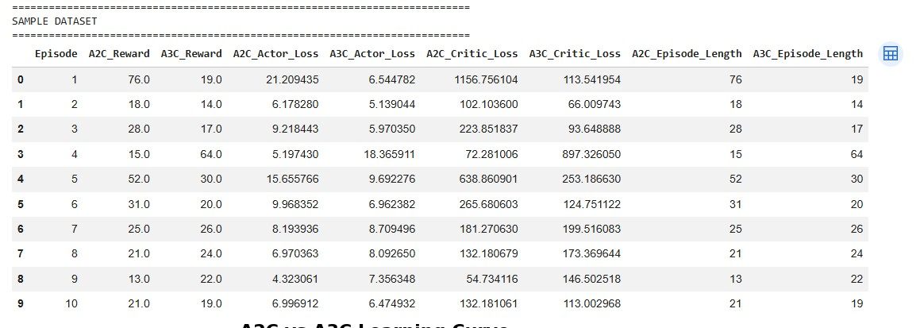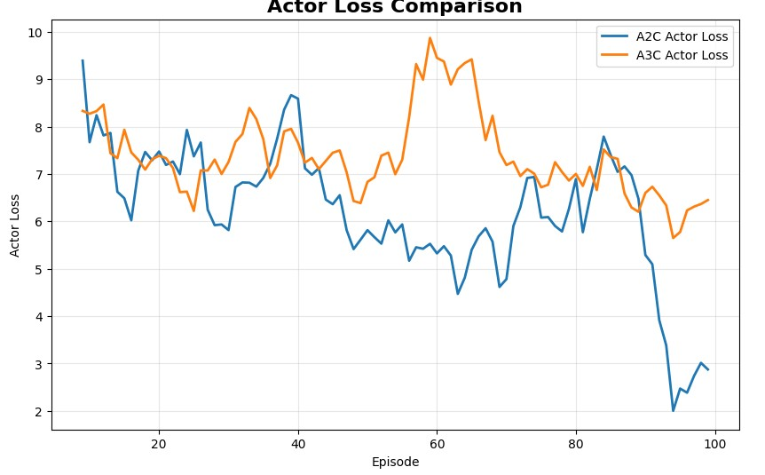
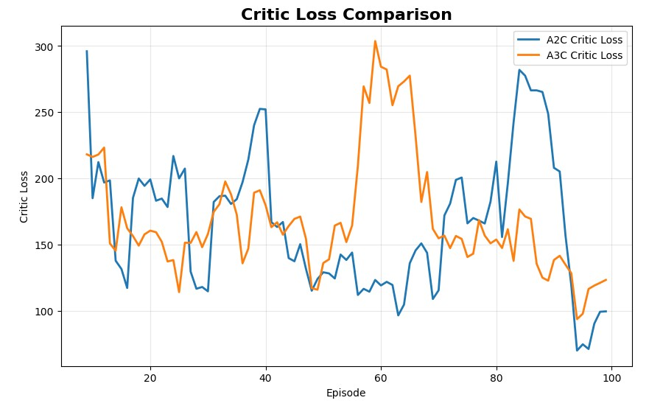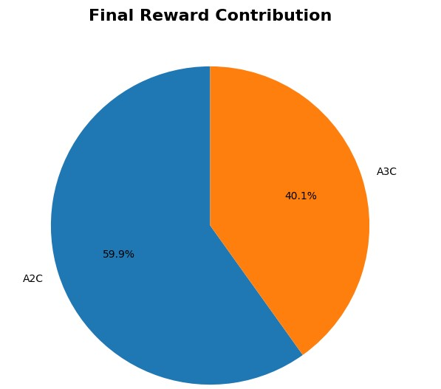

Summary Table

Parameter | A2C | A3C
Environment | CartPole-v1 | CartPole-v1
Final Reward | Obtained from program | Obtained from program
Reward Variance | Obtained from program | Obtained from program
Average Steps | Obtained from program | Obtained from program
Training Time | Obtained from program | Obtained from program

Result
The A2C and A3C Actor–Critic algorithms were successfully implemented using TensorFlow, Keras, and Gymnasium. The actor learned the action policy while the critic estimated the value of states. Their learning performance was compared using rewards, variance, actor loss, critic loss, episode length, and training time.

